**Create, Schedule & Restore Ansible-Server Snapshot**

This document assumes that you have prior knowledge about the Google Cloud Platform (GCP).

* Firstly, Go to the **Compute Engine >> Disks**
* Click on the disk **Name**, for which you want to create a Schedule Snapshot.

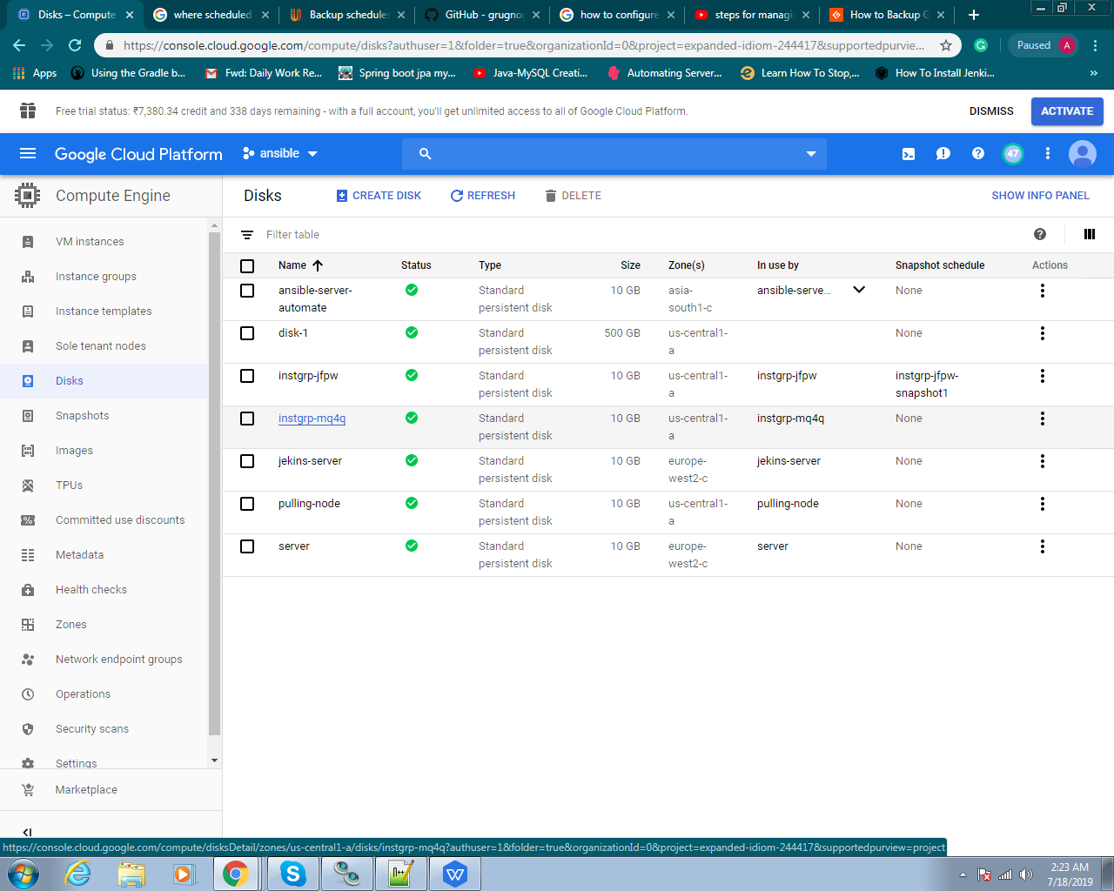

* Click on the **Edit** Button.

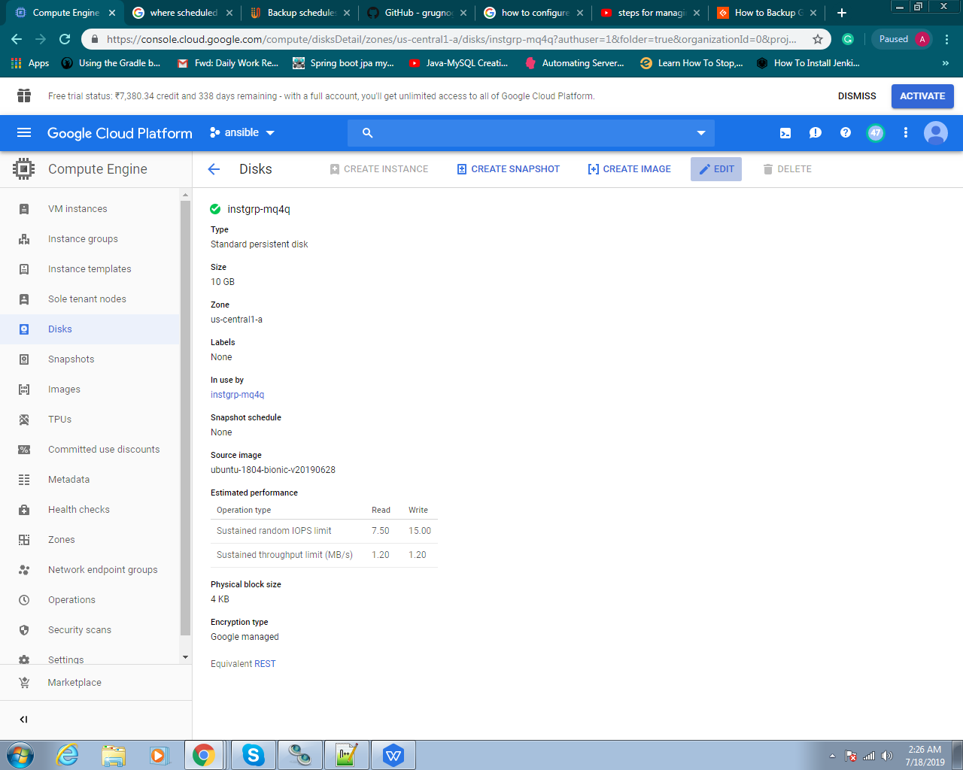

* After this, set the **Size** of the disk.
* **Create Schedule** under the **Snapshot Schedule**

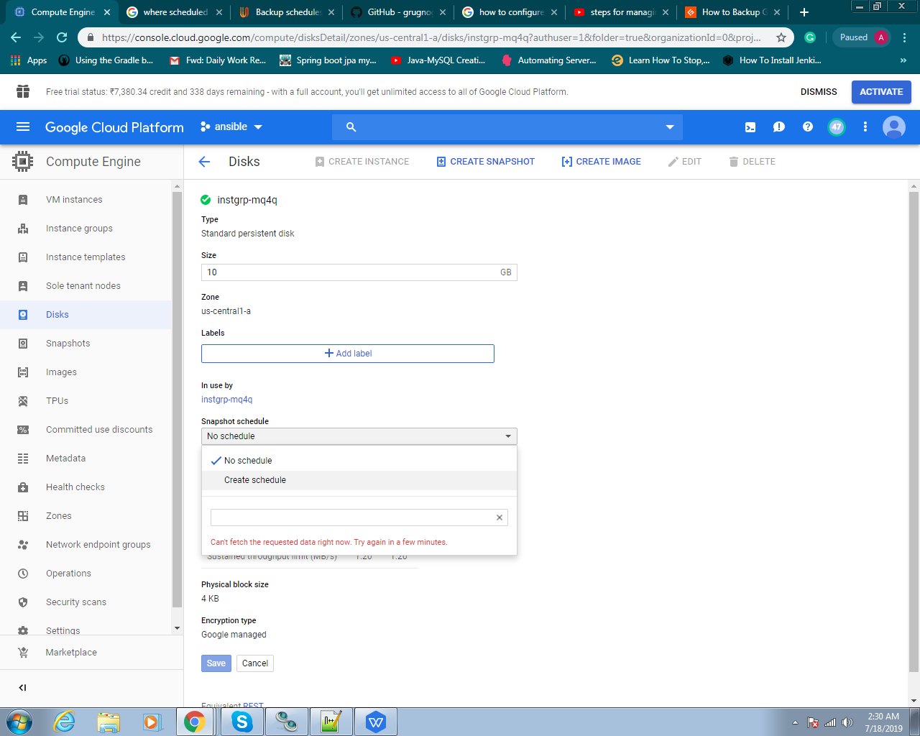

* Following window will appear.

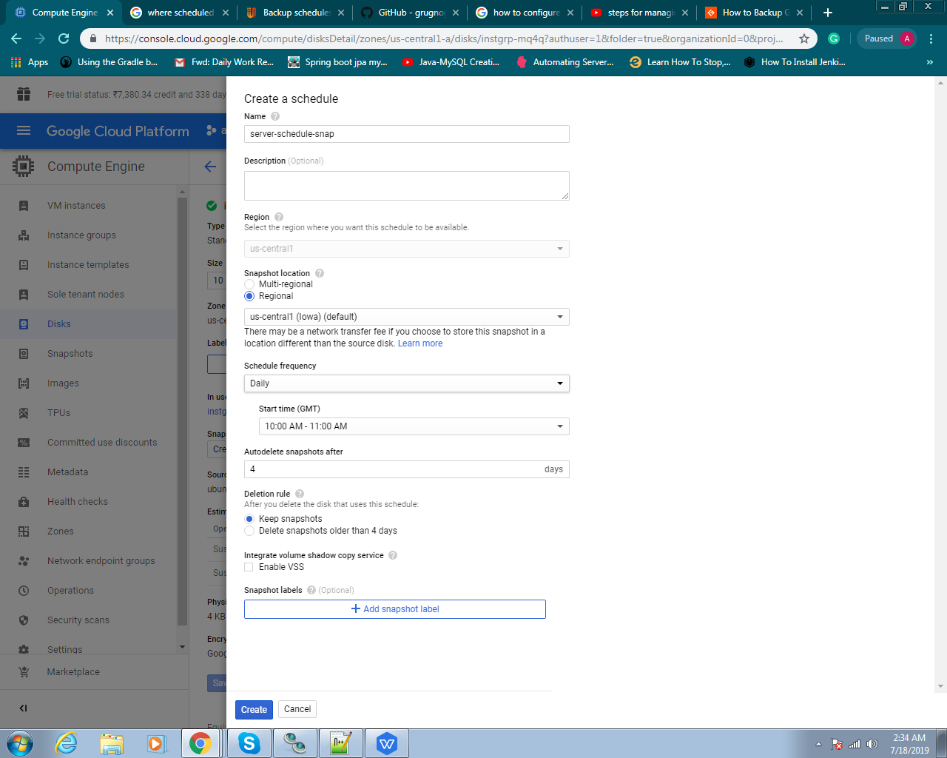

* After this, give the **Name** of your snapshot, select the **Region**, set the **Schedule Frequency (**on the **daily, hourly** and **weekly** bases**)**, set the **Start time**, set **Autodeletetion** of the snapshot.
* Click on the **Create** button.
* After Creation of the schedule snapshot, click on the **Save** Button.

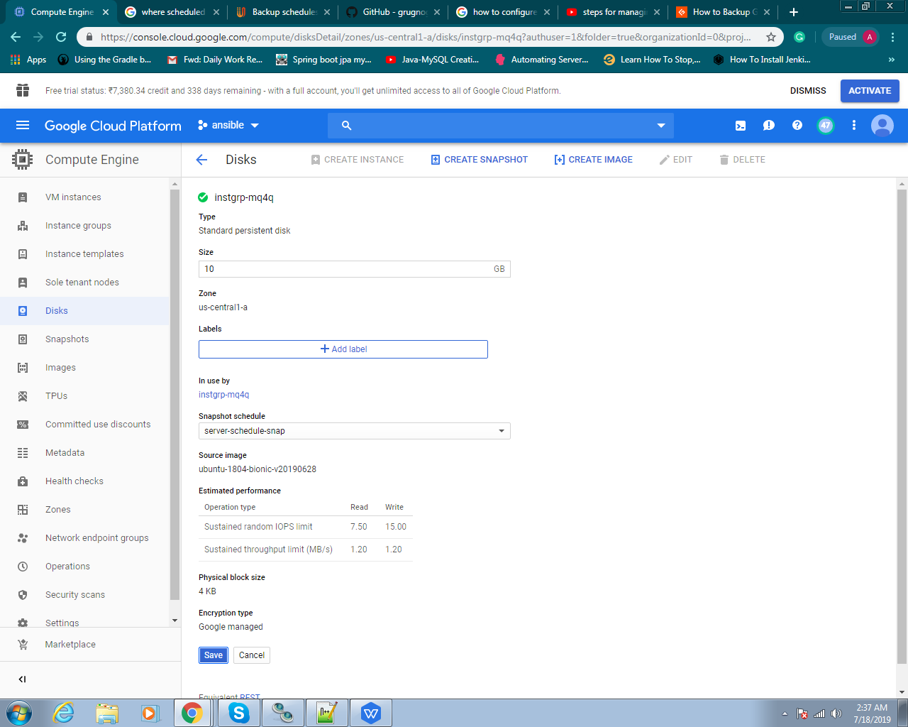

* Go back to the Disks window and this will appear on your screen.

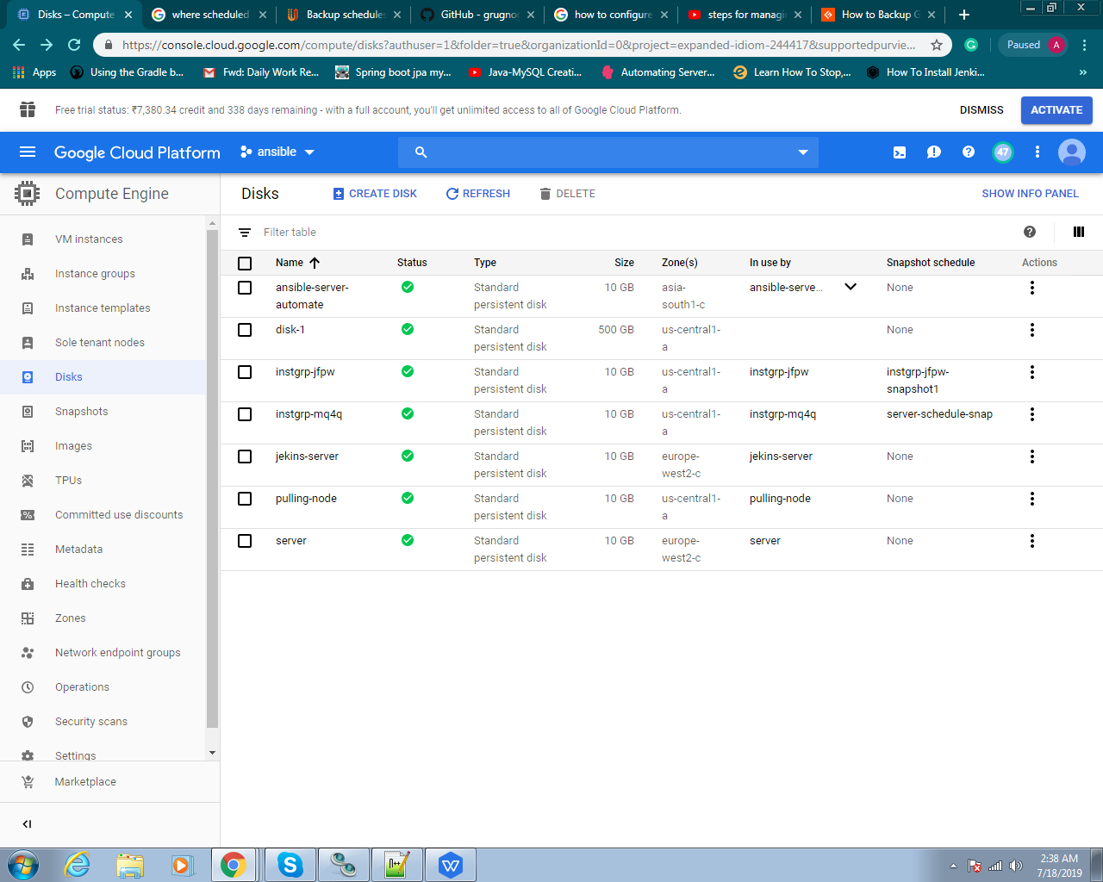

* You can check your Snapshot in **Compute Engine >> Snapshots** into the **Snapshots** tab. The snapshot only appear after the Schedule time, that you have set in your Schedule Snapshot.

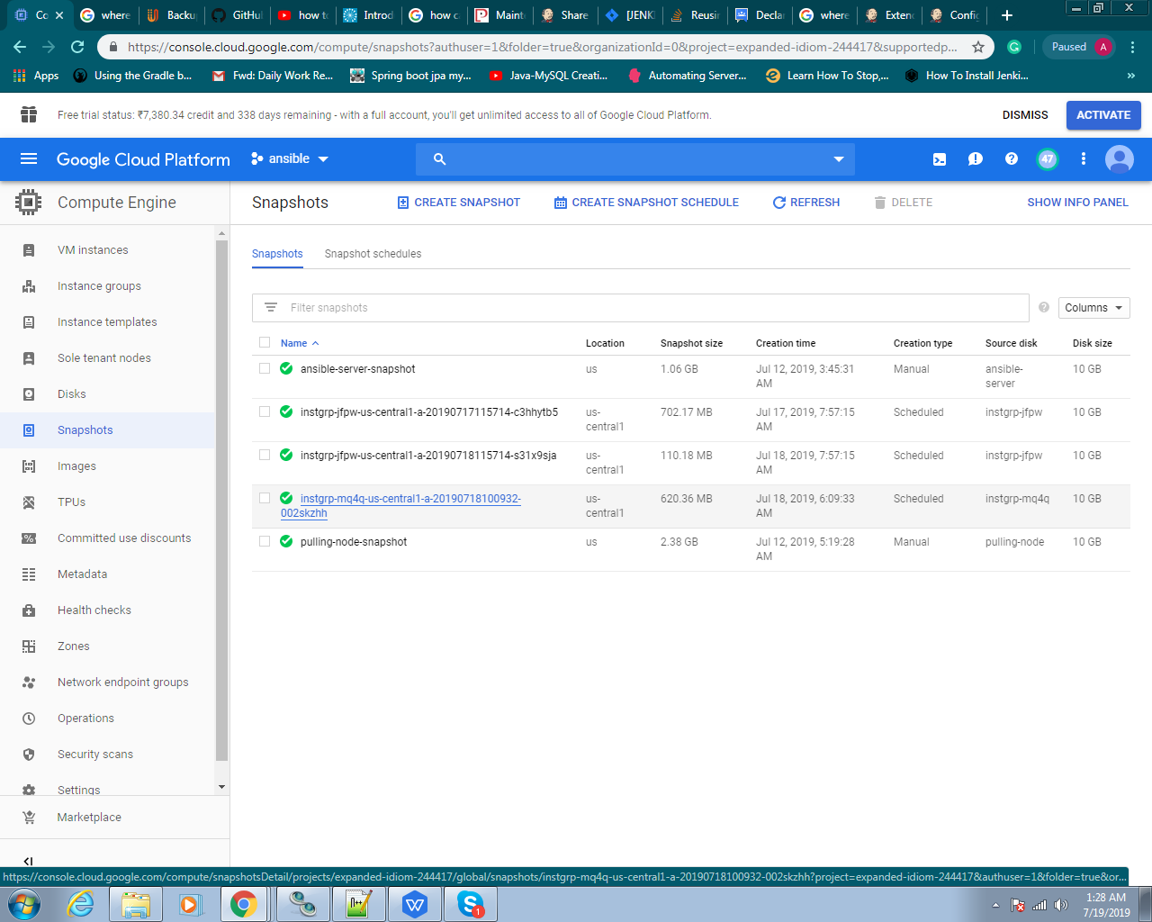

Now you are able to create the VM instance by click on the **Name** of Snapshot under the **Snapshots tab.**

**Creation of VM using Snapshot :-**

* Following screen will appear. Then click on the **Create Instances** option**.**

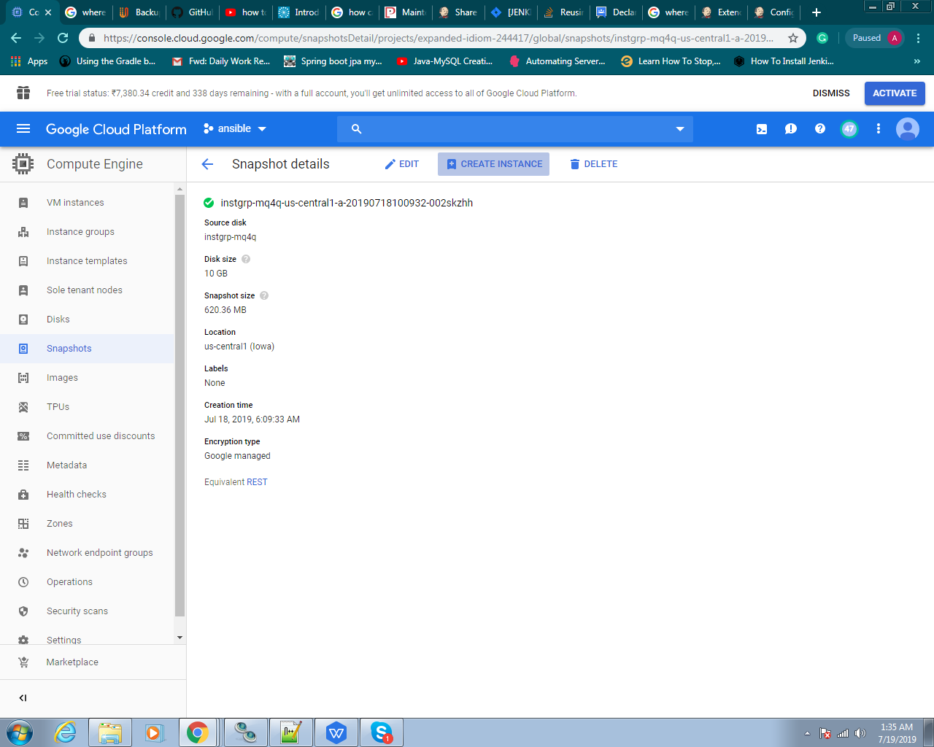

* Give the **Name** of your instance, and check the (**Allow HTTP traffic**) in the **Firewall** option. Then click on the **Create** button.

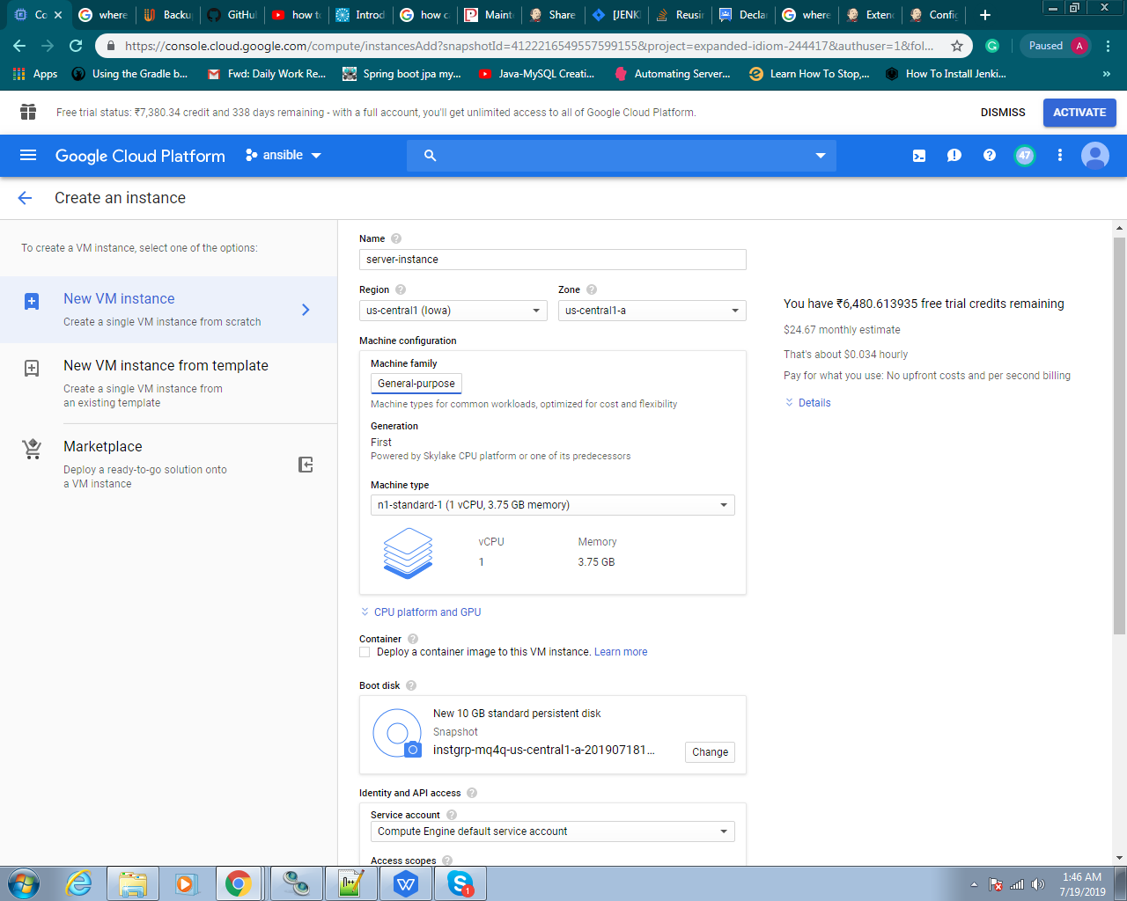

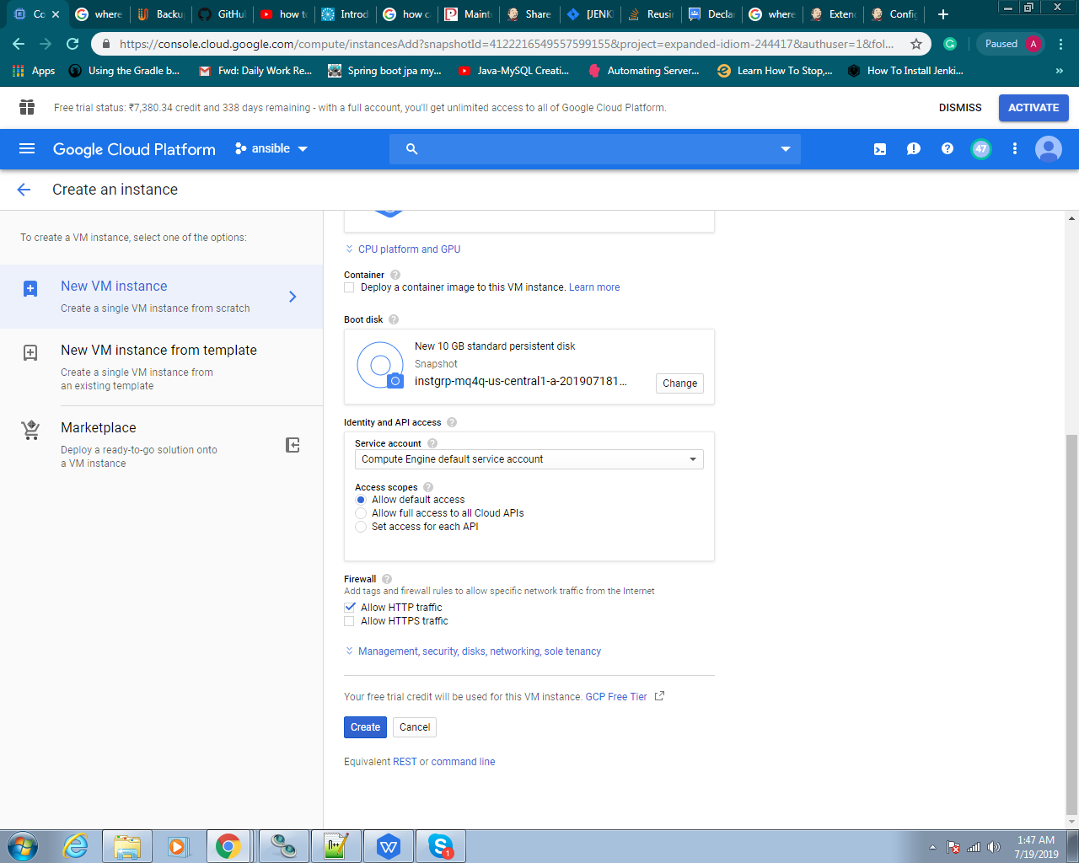

* Now you can see your new VM instance is ready to use with the same configuration of original VM.

